Task 1:

What kind of collision resolution strategy is implemented in the below Hash Table ? import java.util.*; class Task01 { LinkedList<Entry>[] data = new LinkedList[10]; public void put(String keyval, int value) { int index = Math.abs(keyval.hashCode() % data.length); if (data[index] == null) { data[index] = new LinkedList<>(); } for (Entry e : data[index]) { if (e.keyval.equals(keyval)) { e.value = value; return; } } data[index].add(new Entry(keyval, value)); } static class Entry { String keyval; int value; Entry(String k, int v) { keyval = k; value = v; } } }

**Separate Chaining with Linked Lists**

Task02:

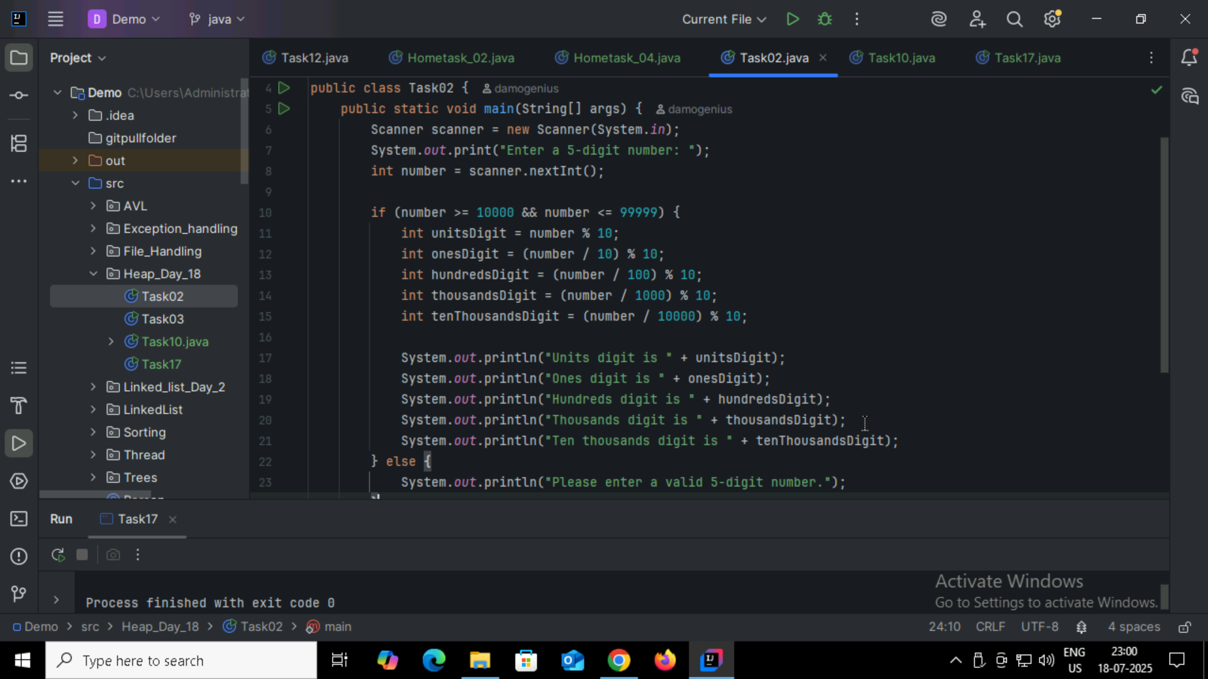

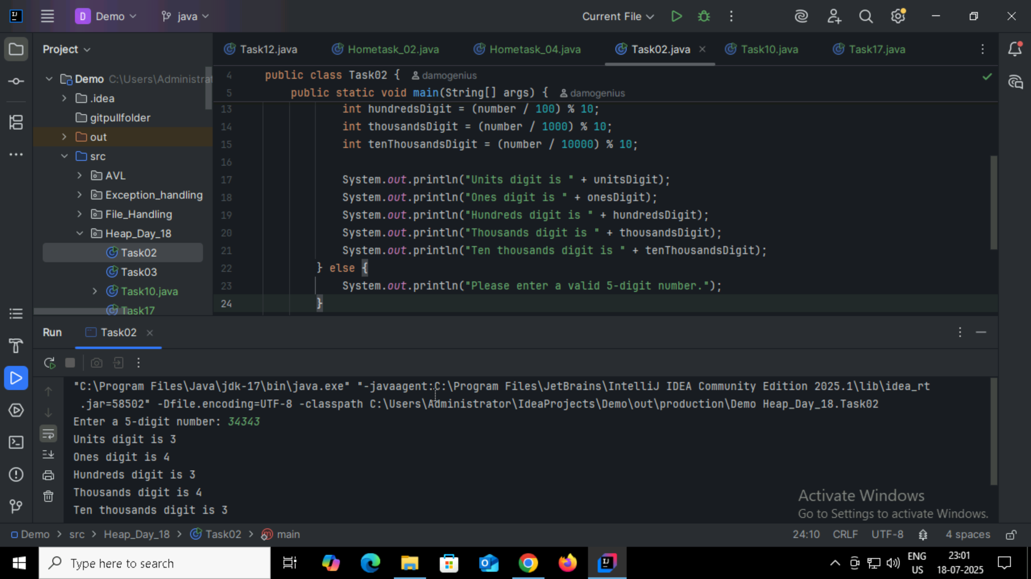

Task03:

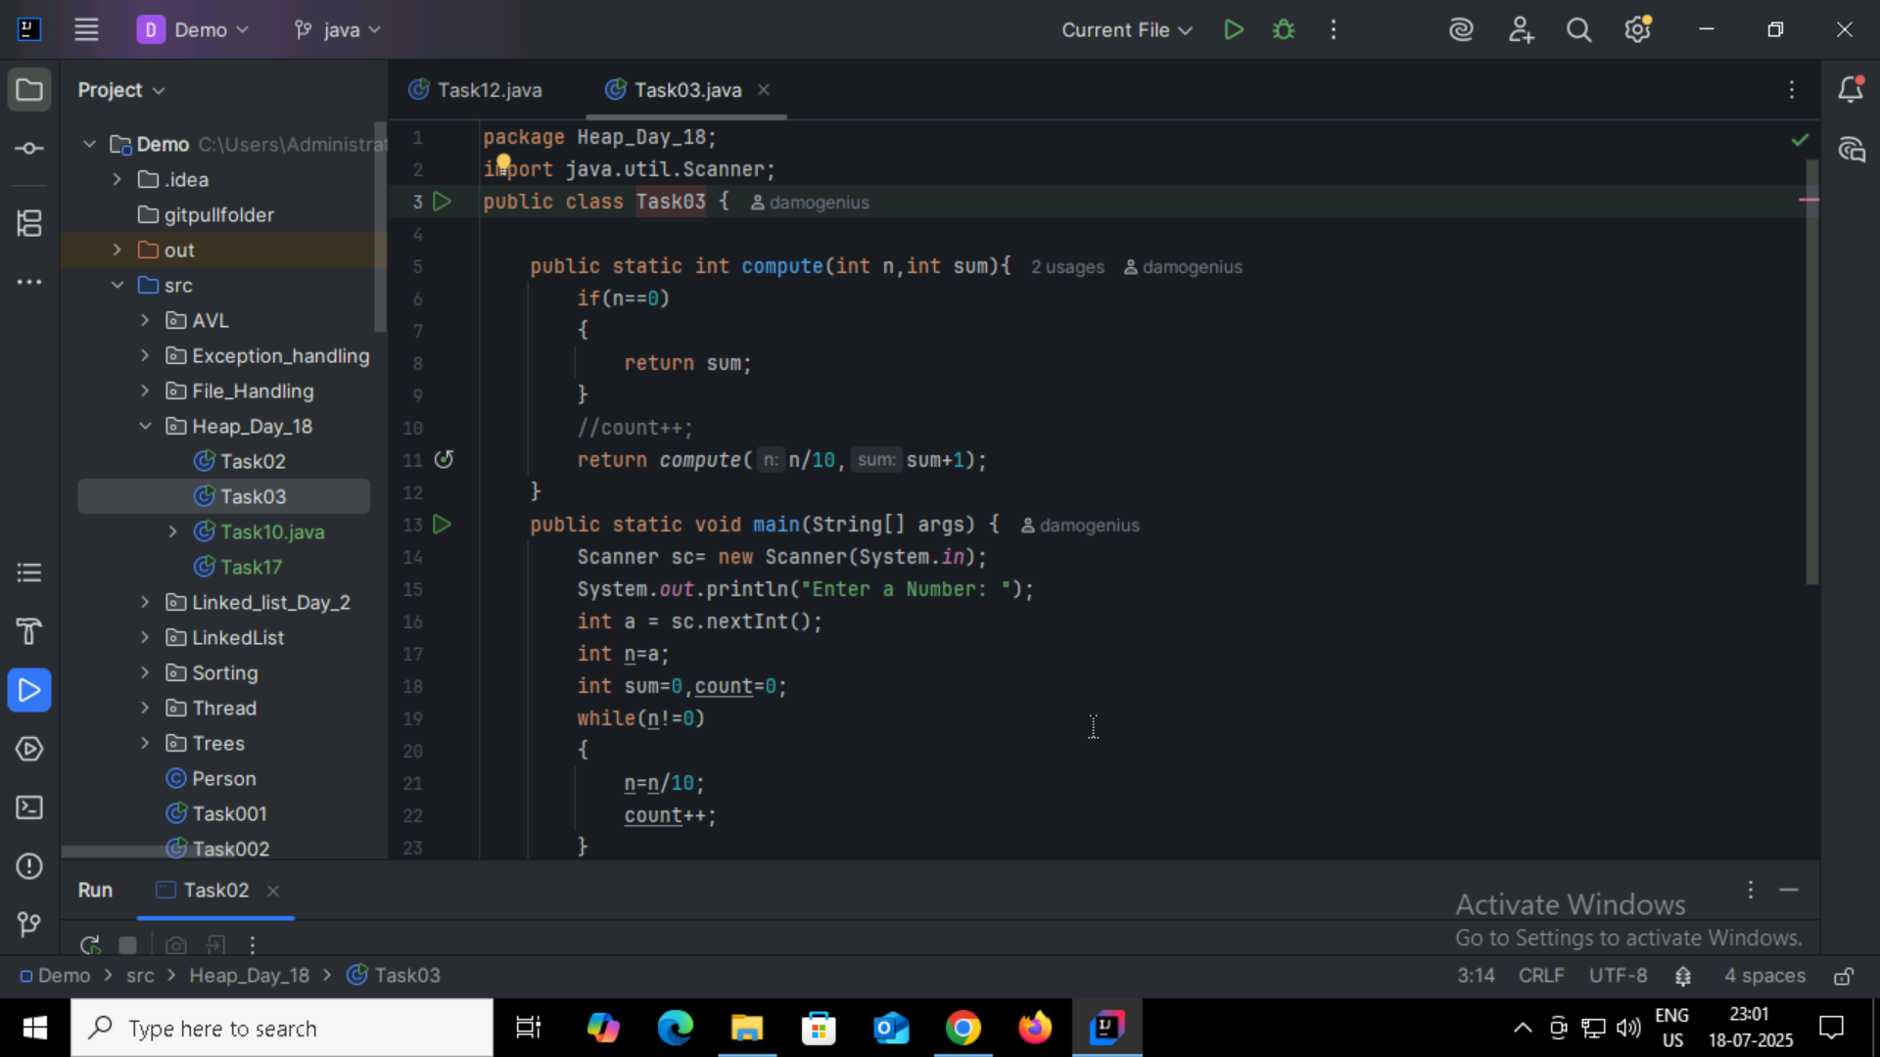

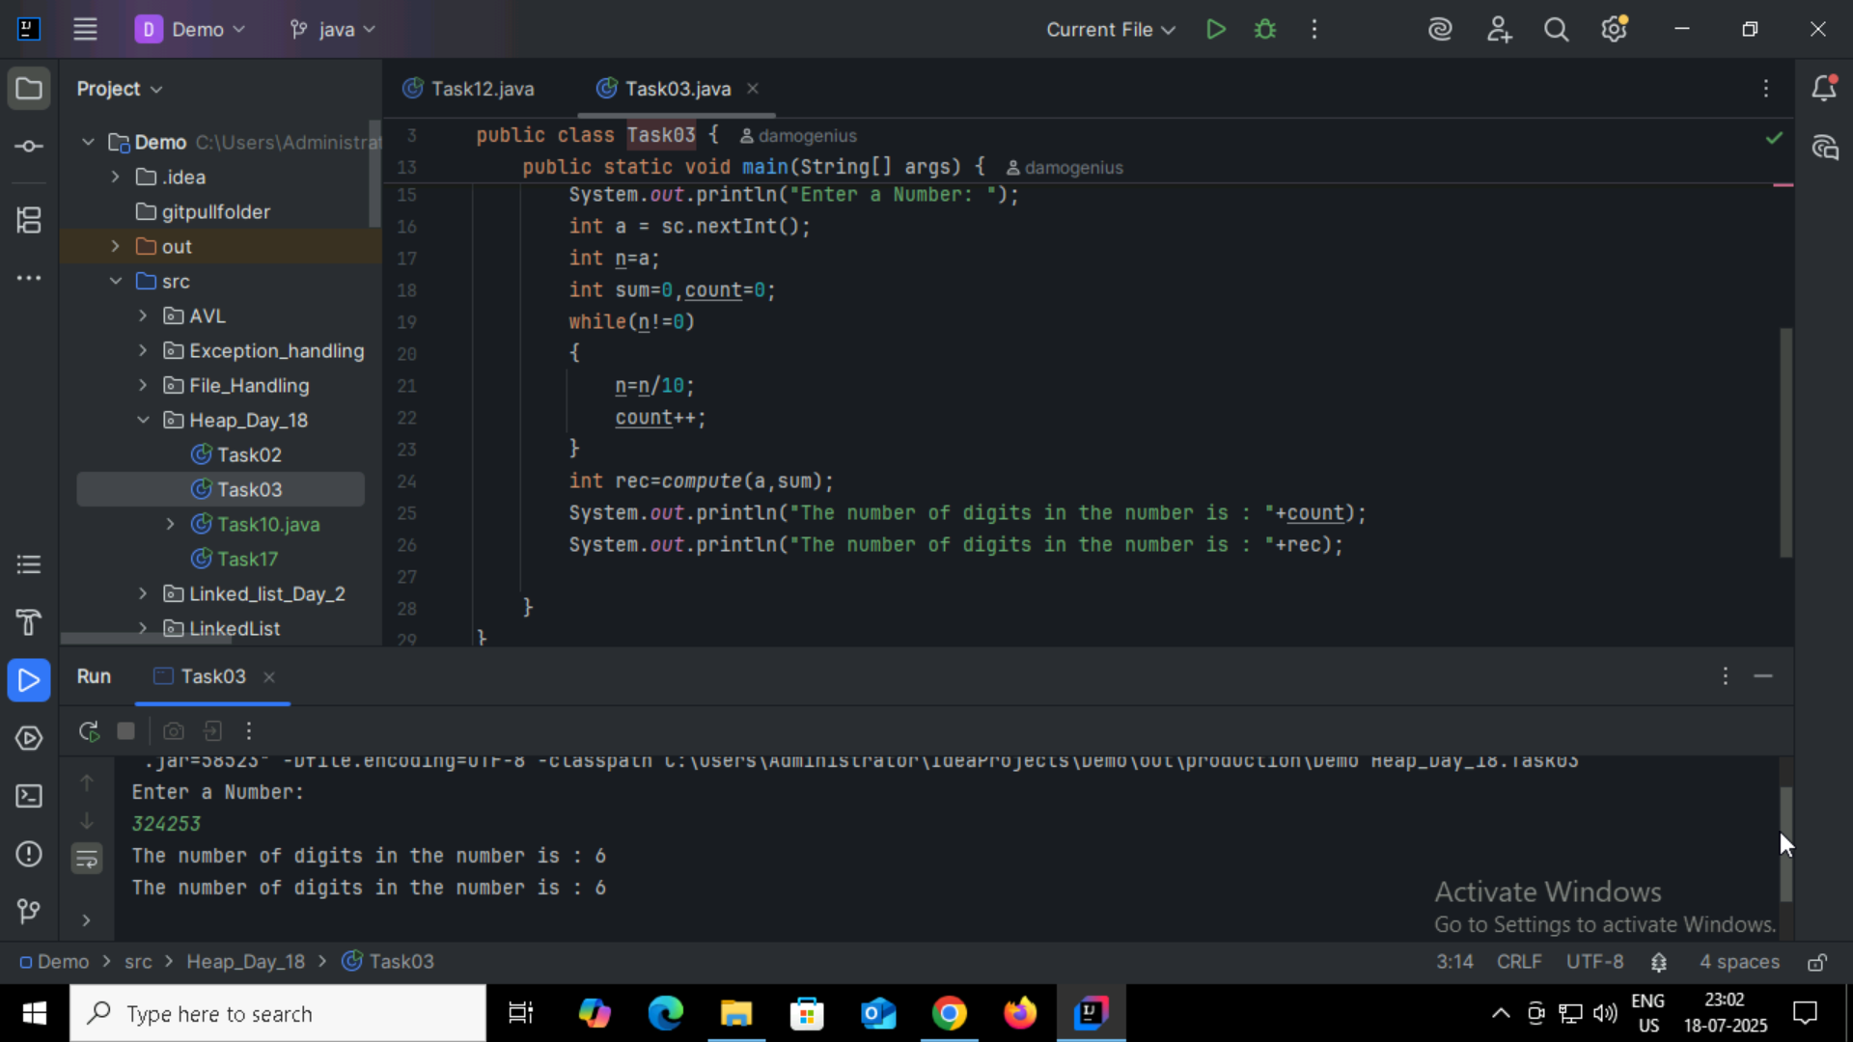

Task 4:

* Sorting Large Data with Limited Memory
* Priority Queue Implementations
* Real-time Systems (Predictable Performance)
* Median or Kth Element Problems
* Event-driven Simulations
* Job Scheduling
* Embedded Systems Sorting

Task 5:

Do you find any significance change between the breadthFirstSearchRecursive() approach compared to the standard BFS?

Will it need for queues entirely by using a stack-based recursion?

Will it simplifies implementation by using queues implicitly within recursive function calls?

**will it achieve same result but emphasizes on recursive style using the same level-order logic with explicit queue management?**

will it processes nodes in post-order sequence to avoid memory allocation?

Task 6:

Step 1: Build a Max Heap

Convert the input array into a Max Heap, where the largest element is at the root.

This ensures the parent node is always greater than its children.

Step 2: Swap Root with Last Element

Swap the root (maximum element) with the last element in the heap.

This places the largest element at its correct sorted position (end of the array).

Step 3: Reduce Heap Size

Consider the heap to be one element smaller (ignore the last element as it's now sorted).

This maintains a shrinking unsorted portion.

Step 4: Heapify the Root

Apply heapify to the root to restore the Max Heap property.

Push the new root down the heap until it is in the correct position.

Step 5: Repeat Until Sorted

Repeat steps 2–4 for the remaining unsorted portion of the array.

After each iteration, the next largest element moves to its correct place.

Task 7:

how can you say recursive functions maintain the state of each call during execution?

1. Each recursive call creates a new thread, and context switching maintains state.

2. Recursive functions store state in global variables accessible across calls.

**3. The system call stack tracks local variables and return addresses for each recursive invocation.**

4. Recursive functions replicate the heap structure to keep values between calls.

Task08:

Which property of a priority queue differentiates it most from a regular queue implementation?

1. It allows insertion and removal only from one end, similar to a stack.

2. Elements are removed based on their order of insertion rather than priority.

**3. Elements are dequeued based on their priority, not their insertion order, often implemented using a binary heap.**

4. It maintains a strict hierarchical structure using a self-balancing BST to enforce priority.

Task09:

What is the main purpose of using a binary heap in the implementation of a priority queue?

1. To maintain keys in alphabetical order for efficient string processing.

**2. To ensure that the highest-priority element always bubbles to the root efficiently.**

3. To guarantee constant-time insertion and logarithmic-time deletion.

4. To reduce memory consumption by flattening the tree into a linear array.

Task10:

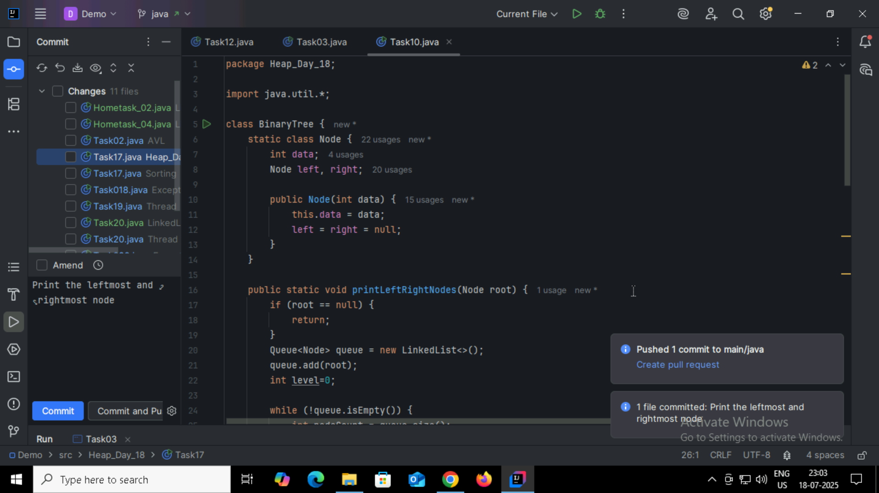

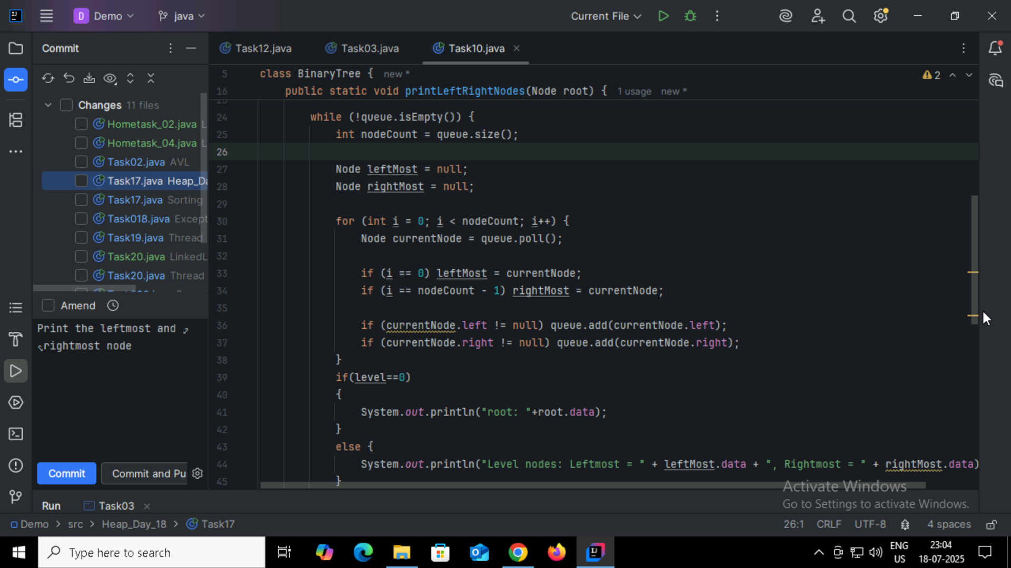

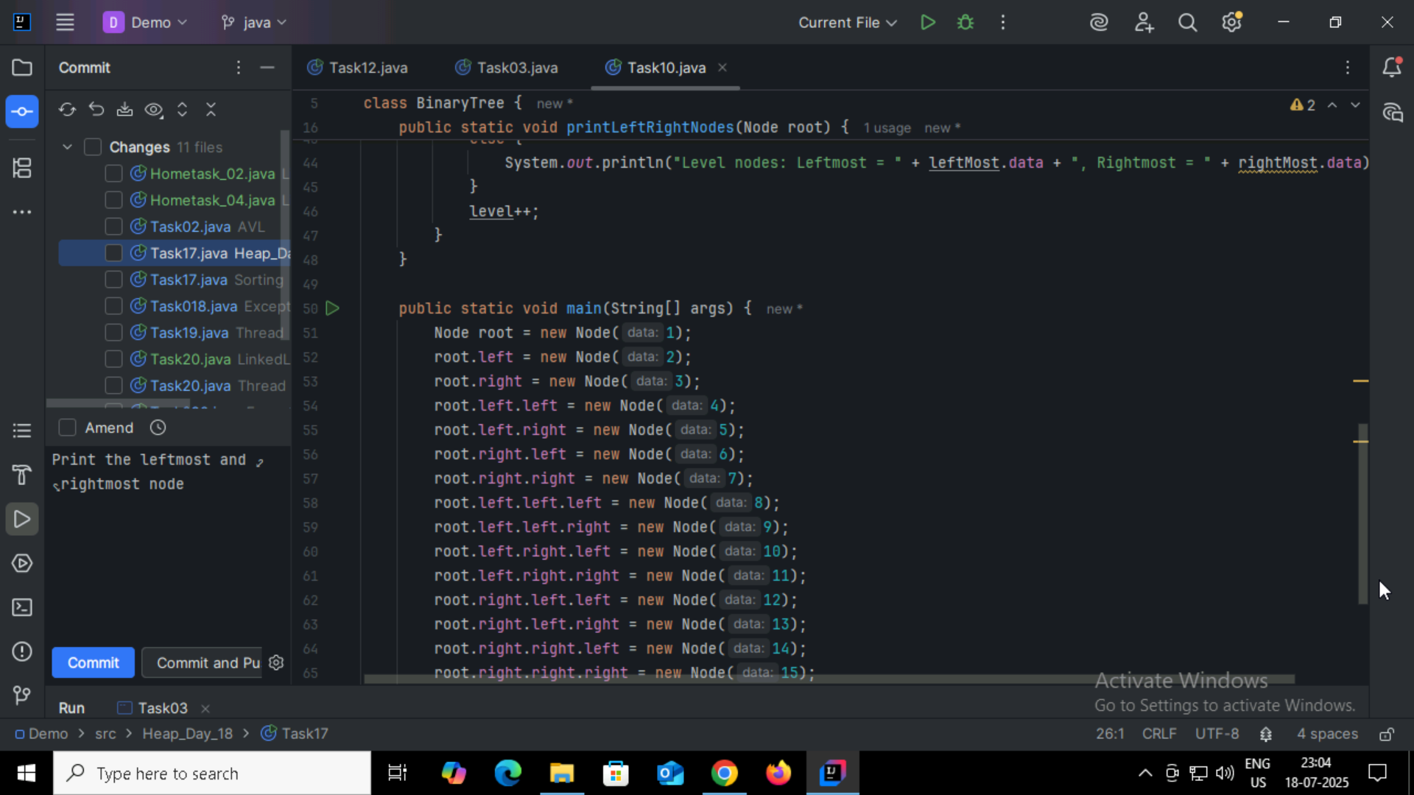

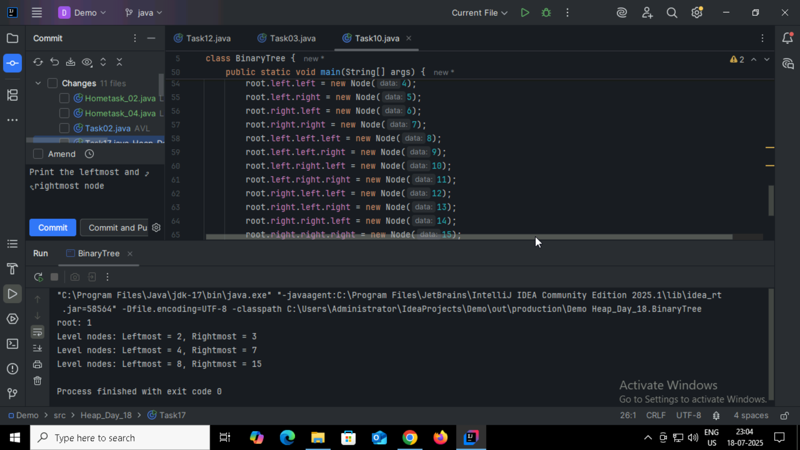

Task11:

Which concept explains how recursive functions maintain the state of each call during execution?

1. Each recursive call creates a new thread, and context switching maintains state.

2. Recursive functions store state in global variables accessible across calls.

**3. The system call stack tracks local variables and return addresses for each recursive invocation.**

4. Recursive functions replicate the heap structure to keep values between calls.

Task 12:

How does this binary search function behave on unsorted arrays?

public class BinarySearch {

    public int search(int[] arr, int target) {

        int left = 0, right = arr.length - 1;

        while (left <= right) {

            int mid = left + (right - left) / 2;

            if (arr[mid] == target) {

                return mid;

            } else if (arr[mid] < target) {

                left = mid + 1;

            } else {

                right = mid - 1;

            }

        }

        return -1;

    }

}

1. It works regardless of sorting

2. It throws exception if unsorted

**3. It may return incorrect index**

4. It sorts before searching

Task 13:

What is the result of performing DFS traversal in this graph implementation?

import java.util.*;

public class DFSGraph {

     Map<Integer, List<Integer>> adj = new HashMap<>();

     Set<Integer> visited = new HashSet<>();

     public void addEdge(int u, int v) {

        adj.computeIfAbsent(u, x -> new ArrayList<>()).add(v);

    }

     public void dfs(int node) {

        if (visited.contains(node)) {

            return;

        }

        visited.add(node);

        System.out.print(node + " ");

        for (int neighbor : adj.getOrDefault(node, new ArrayList<>())) {

            dfs(neighbor);

        }

    }

}

1. DFS uses a queue to ensure order

2. DFS will return shortest path like BFS

**3. DFS traverses all nodes depth-first recursively**

4. DFS skips connected nodes due to reentrancy issue

Task 14:

Why is BFS generally preferred over DFS in shortest path algorithms for unweighted graphs?

1. BFS uses random access to edges, ensuring constant-time traversal.

2. BFS explores one path to maximum depth before switching, reducing memory usage.

3. BFS ignores revisiting nodes, reducing processing time in cyclic graphs.

**4. BFS explores nodes in increasing distance order from the source, ensuring shortest paths are found first.**

Task 15:

1. Find the maximum number in the array to determine the number of digits (d).

2. For each digit place (starting from least significant digit to most significant digit):

a. Perform a stable counting sort based on the current digit.

(i.e., sort numbers based on 1s place, then 10s, then 100s, etc.)

3. Return the sorted array.

Task16:

RADIX_SORT(arr)

maxNum = FIND_MAX(arr)

digitPlace = 1

while (maxNum / digitPlace) > 0

COUNTING_SORT_BY_DIGIT(arr, digitPlace)

digitPlace = digitPlace × 10

Task17:

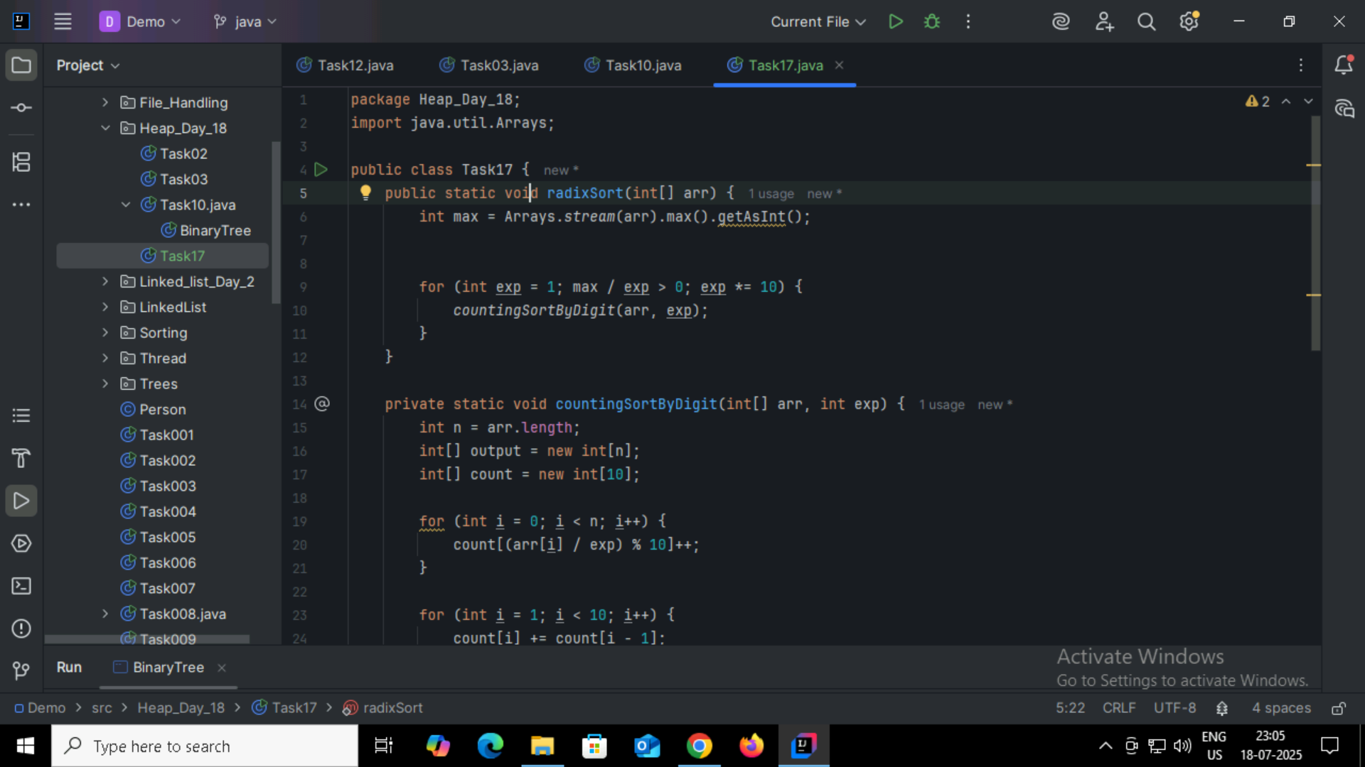

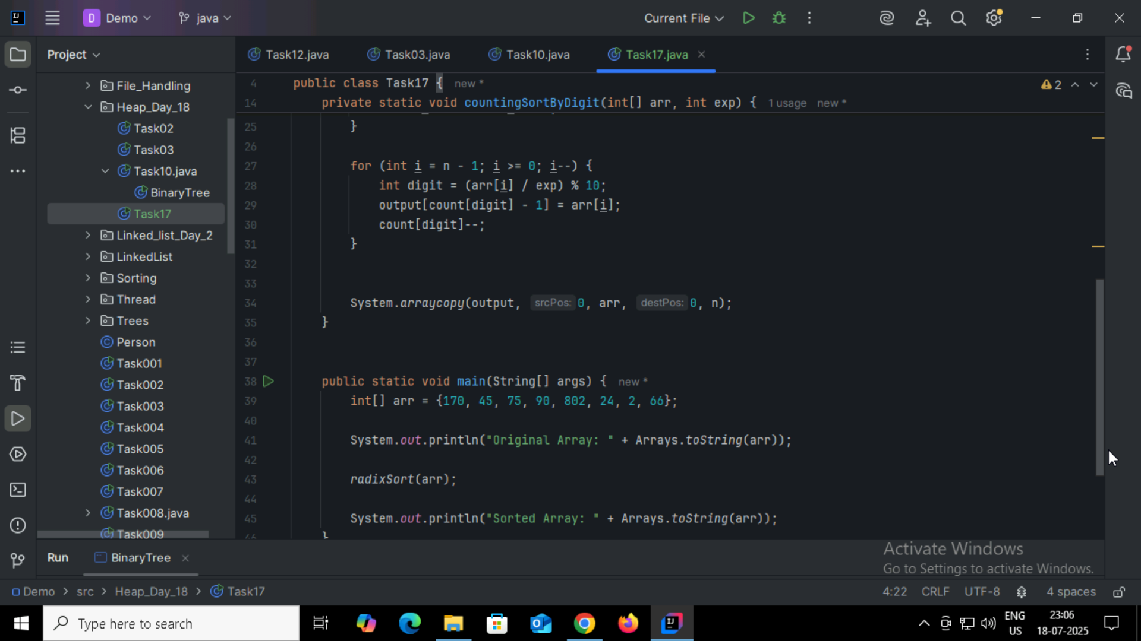

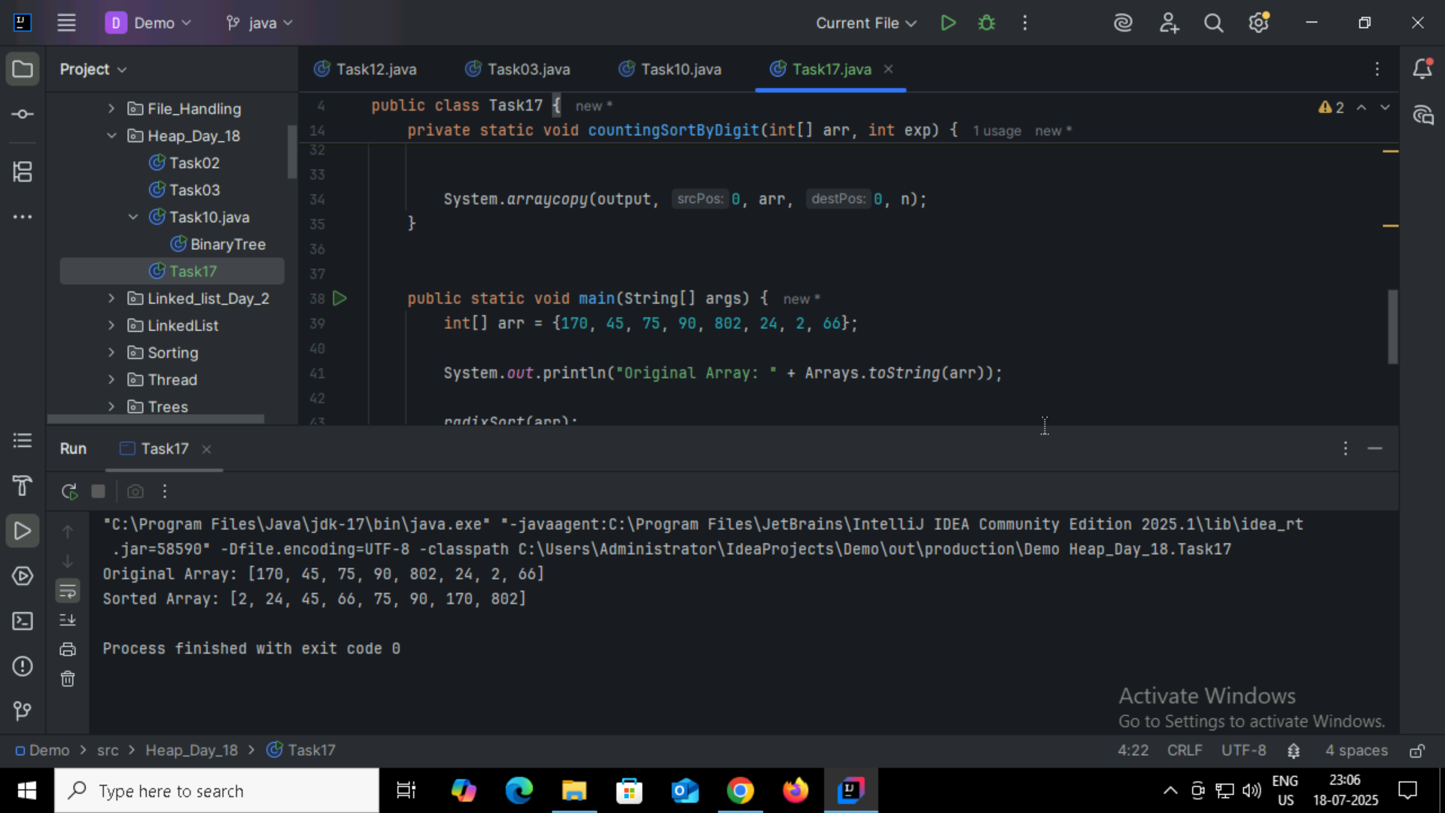

Task18:

What causes a stack overflow error in recursive functions?

1. Excessive memory allocation in the heap due to global variables.

2. Infinite iteration loops that do not update the loop variable.

3**. Recursion that lacks a proper base case or makes too many nested calls, exhausting the call stack**.

4. Function calls that return too quickly without completing the recursion tree. Recursion that lacks a proper base case or makes too many nested calls, exhausting the call stack.

Task19:

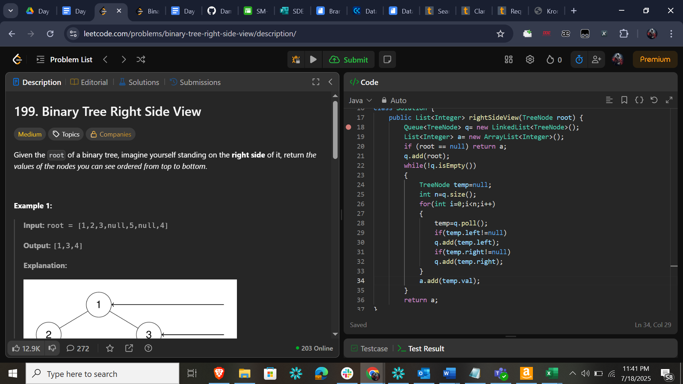

Home Task 018:

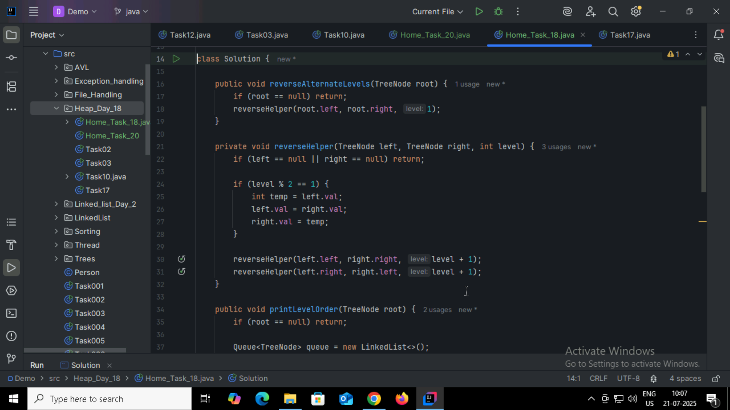

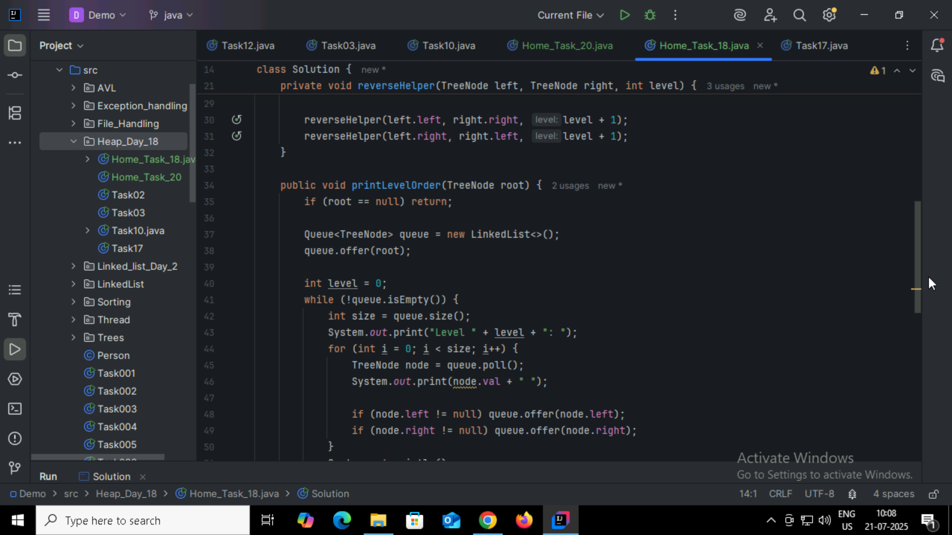

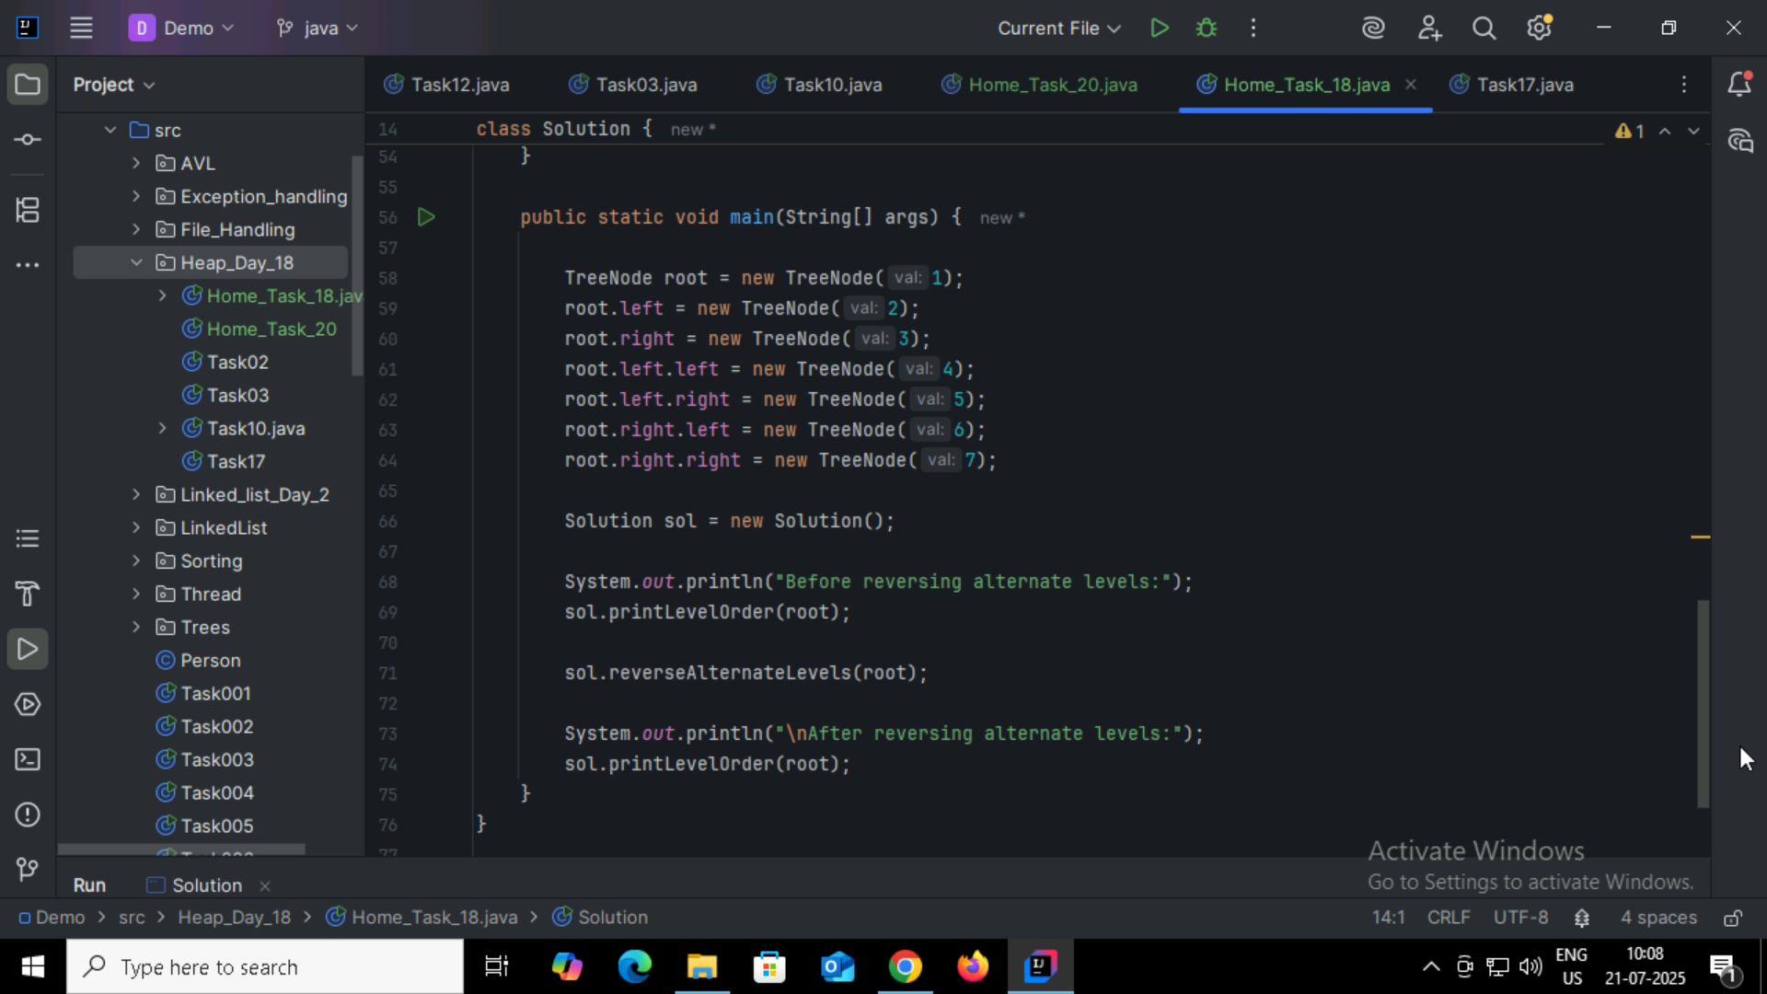

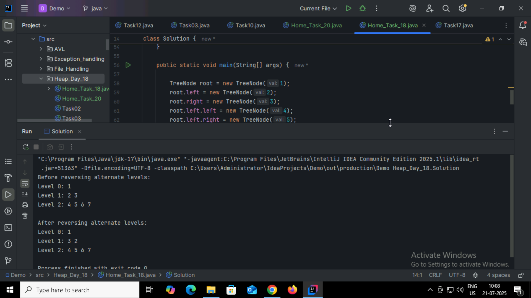

Home_Task20:

